REQUIREMENTS DOCUMENT TEMPLATE

[Feature Name ]



Version 1.0

[Company Name]
[Company Address]

[Remember to update header and footer as well]
Business Problem 4
Solutions Overview 4
Assumptions 4
Risks 4
In Scope 4
Out of Scope 5
Requirements 6
Wireframes: 7
Technical Design/Notes 8
Estimation Points 8
Decisions 8

Revision History
Date | Version | Change Description | Author
3/4/2020 | 1 | This enhancement will add hyperlinks automatically to the comment cards | Suzan Jones

Approvals
Date | Name | Notes
3/9/2020 | Kara Leise | Approved to Develop

Business Problem
[Explain the current as-is state – include diagrams where necessary]

Clients have expressed the need to have links on their comment card on the drawing canvas so that they can better reference additional information. This may include links to other internal sources such as their SharePoint documents or Tableau dashboards as well as external links to website or links to social media.

Currently our system does not allow adding clickable links in the comments. Today links appear as plain text when added on the comment card.

Solutions Overview
[Explain the solution that the requirements will provide to the problem above -feel free to add diagrams or move to a separate page ]

To solve this business problem, we will implement the ability to add hyperlinks in the comment cards so that when the user enters a link, the system will automatically detect it and make it clickable.

Assumptions
[List the assumptions made in order to accomplish the solution above -feel free to move to a separate page]

Risks
[List the risks identified and the steps that will be taken to mitigate those risks - feel free to move to a separate page]

In Scope
[List the areas that will be covered in the requirements - feel free to move to a separate page]
- Ability to automatically detect and format a hyperlink entered in a comment card
- Ability to open the hyperlink when clicked

Out of Scope
[List the areas that will not be included in these requirements feel free to move to a separate page]
- Ability to create short links to replace longer hyperlinks

Requirements

- When the user enters text with a prefix of “www”, “http” or “https” on a comment card on the drawing canvas, the system must detect that a hyperlink has been entered and display the text using the hyperlink style (see style guide).

  - If the user entered a link with no prefix but with a “.domain name” suffix (such as in “karaleise.com”), the system must also detect that a hyperlink has been entered and display the text using the hyperlink style.

- When a user clicks on an hyperlink from the comment card, the system must open the link in a new tab.

- Hyperlinks will only consist of standard HTML and will not need to support application parameters

- When the user hovers over an hyperlink on the comment card, a hover-over must show with the text “Hold the Shift Key + Click to follow external link”

Wireframes:

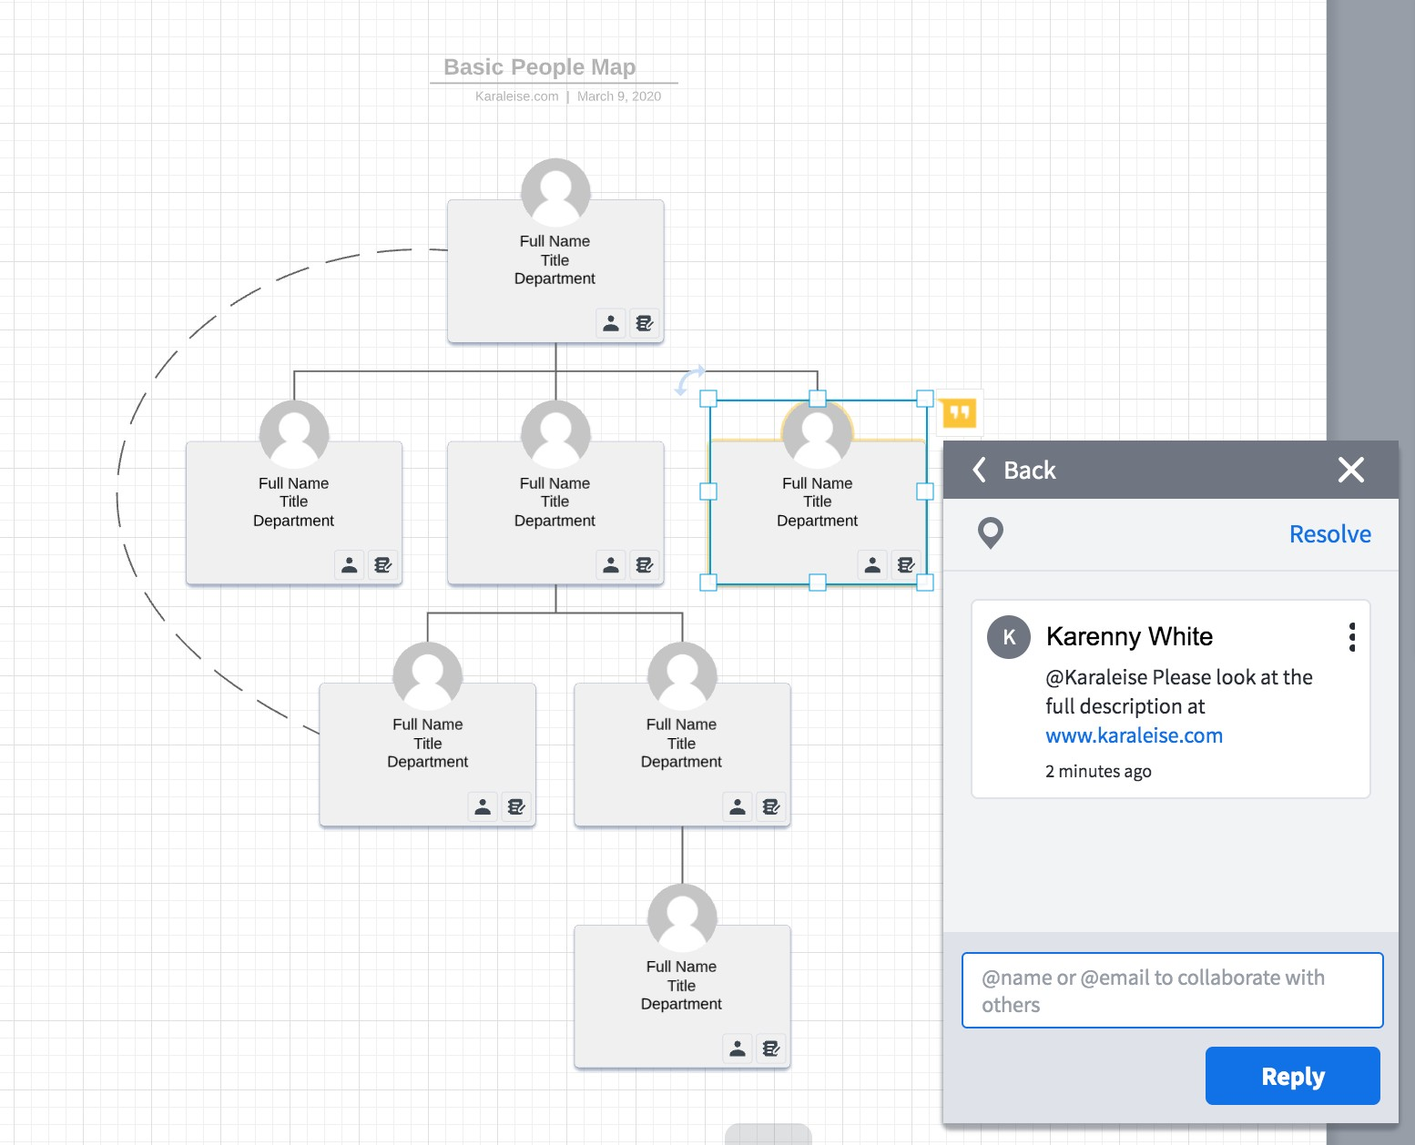

Comment card with hyperlink
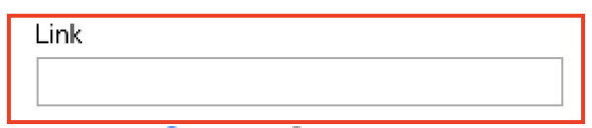
Figure 1- Comment Card with Link

Technical Design/Notes

Estimation Points

Decisions

Decision History
Date | Decision | Decision Maker | Attendees
3/9/2020 | Only keep the hyperlinks on the comment cards for this v2.5 release. The entire card design will be re-evaluated for improved user experience at in a future release. | Karaleise | Stoney Roberts  Ana Walker

